Applied signal processing- SSY130

## Hand in Problem 3

## Object Tracking Using the Kalman Filter

Name: Jahanvi Bhadrashetty Dinesh

Student ID: 20000524

Secret Passphrase: Salazzle

TASK 1:

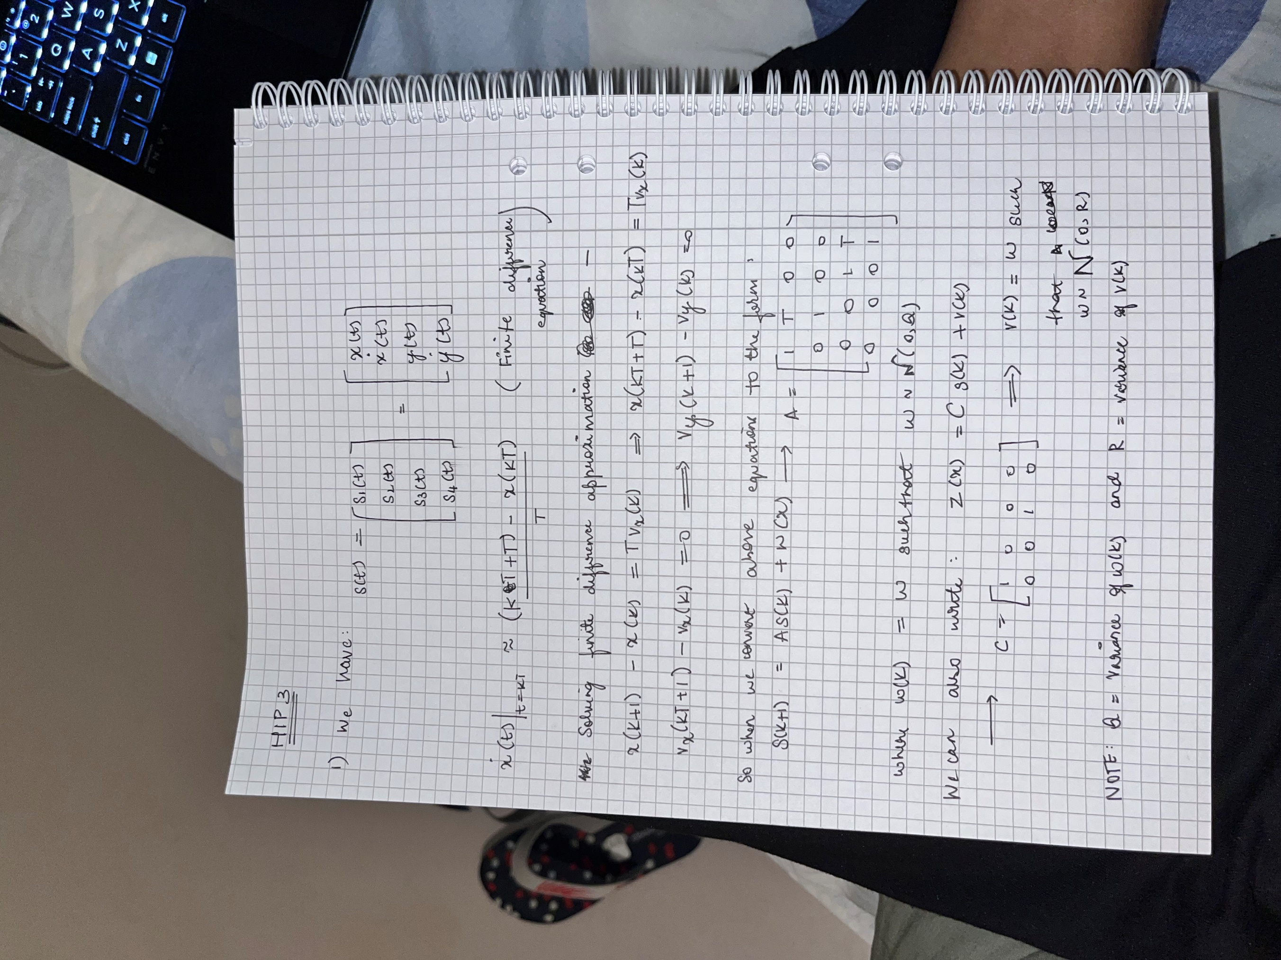

TASK 2:

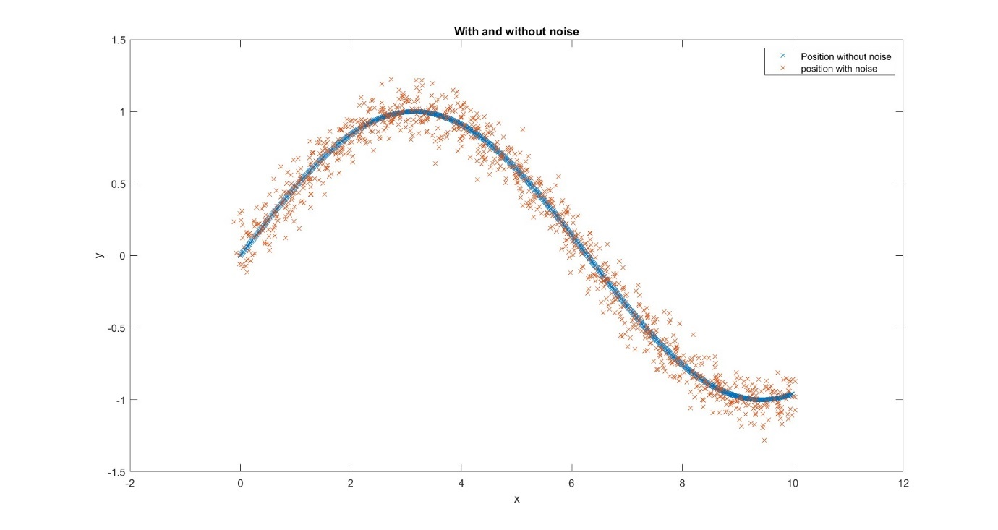

TASK 3:

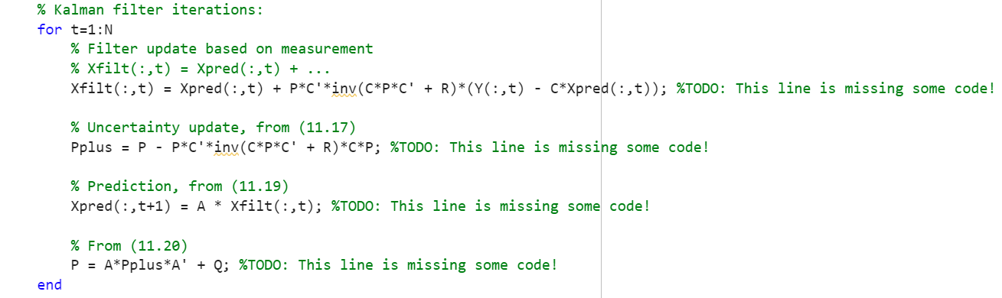

TASK 4:

We need the values of P0, Q and R matrices. Let the covariance matrix P0 be 10^6 . I and let the initial vector is a zero vector.

If we assume that R matrix contains the variance of the noise and Q is the noise, they should be uncorrelated. So we can now find out the co-variance matrix of R as shown in the figure below -

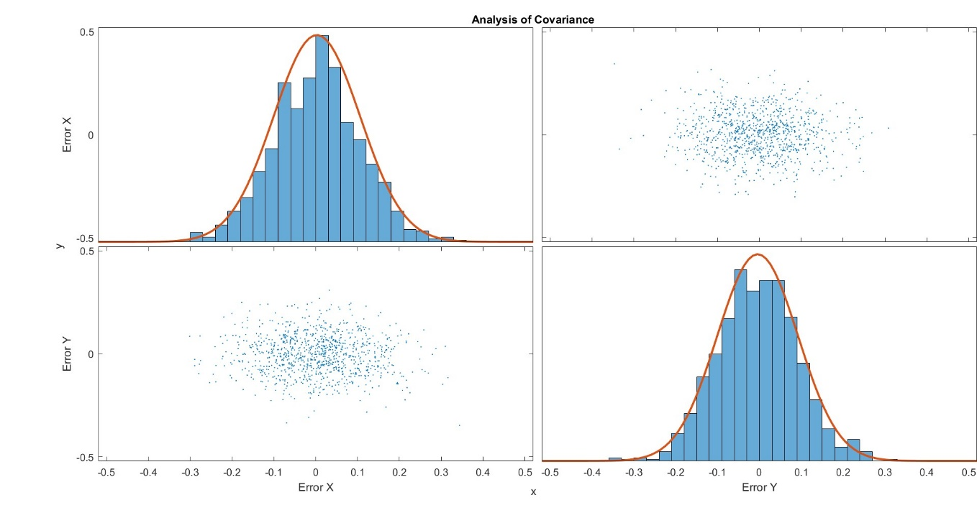

We now have:

However, Q is important to the covariance of noise process but we cannot find Q matrix directly. So we assume an alpha value to describe Q:

Note that here, alpha doesn’t have a fixed value and can be changed based on our needs. This alpha value deeply affects the way the Kalman filter behaves which can be observed in the figure below. We can infer that alpha has an impact on the tracking of velocity. However, doesn’t have too much of an effect on the tracking of position.

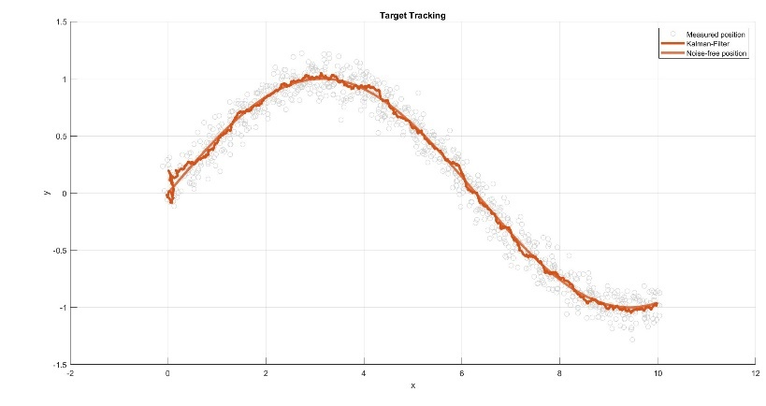

Figure for alpha = 1e-3

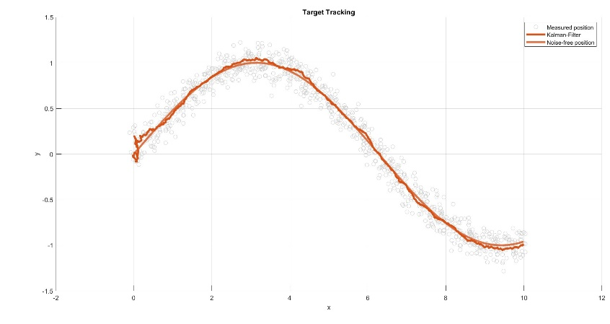

Figure for alpha = 1e-4

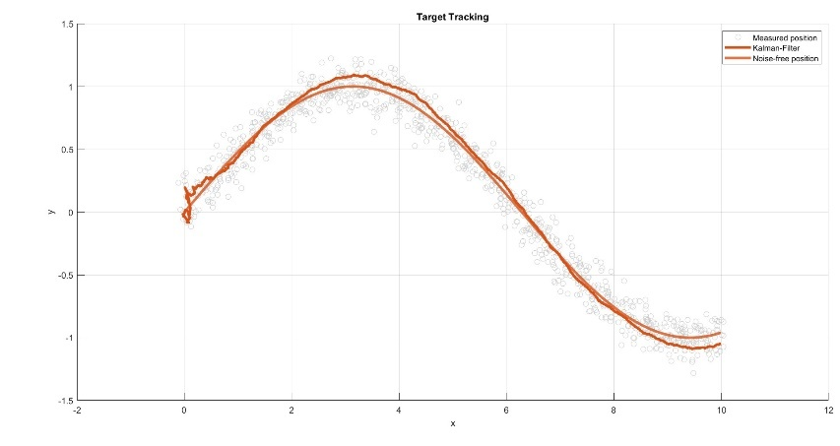

Figure for alpha = 1e-4

Therefore, it is safe to say that taking the derivative of the noisy signal without Kalman filter is a very bad idea with disastrous results. That can be observed from the figures below -

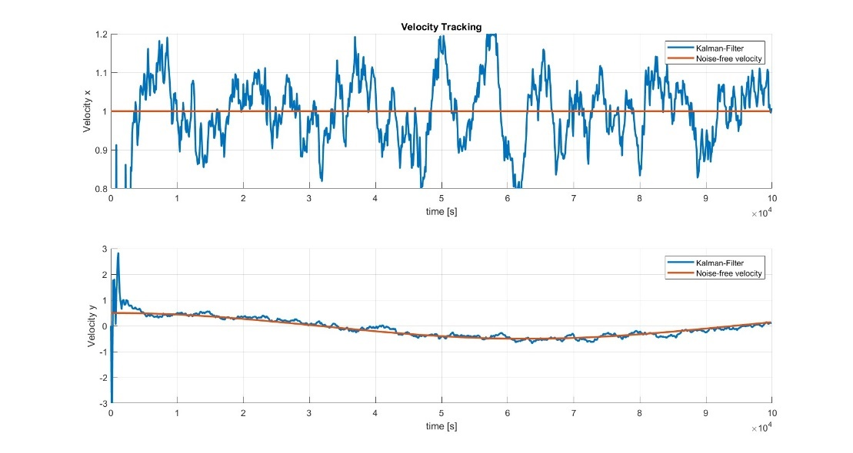

Variance of Velocity tracking with alpha = 1e-3

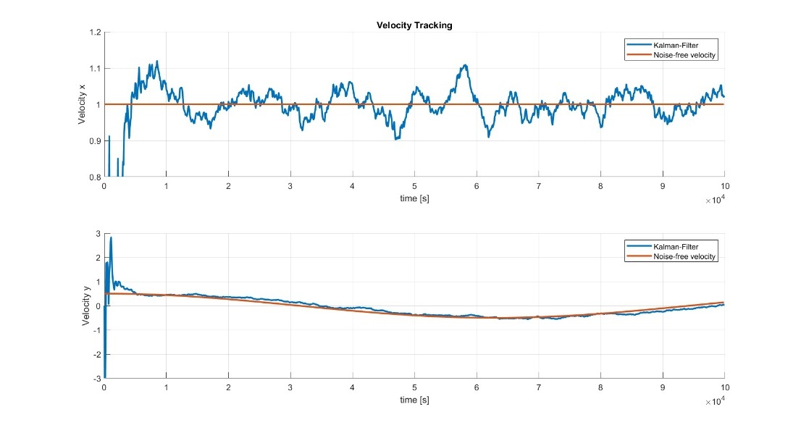

Variance of Velocity tracking with alpha = 1e-4

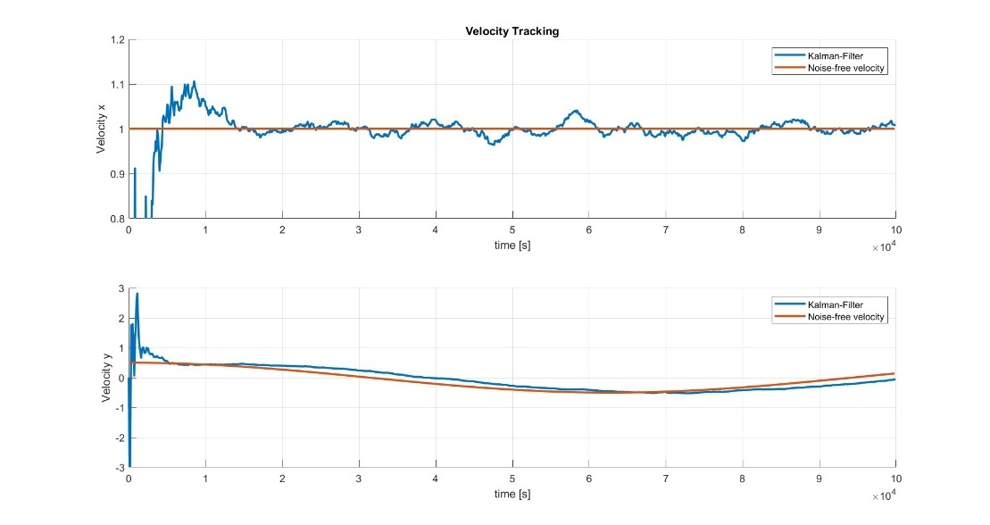

Variance of Velocity tracking with alpha = 1e-5